Seaborn Basics – Histograms, Boxplots, Scatterplots
We’ll use histograms, boxplots, and scatterplots to explore the sleep dataset.

🔍 Difference Between Matplotlib & Seaborn
Feature | Matplotlib | Seaborn
Level | Low-level → gives you full control of every element | High-level → built on Matplotlib, easier defaults
Syntax | More code needed for styling | Cleaner, simpler syntax
Default Style | Basic, sometimes plain-looking | Modern, attractive styles out-of-the-box
Best For | Custom, complex plots where you need full control | Quick, good-looking plots for data exploration

1️⃣ Histogram – Sleep Duration Distribution

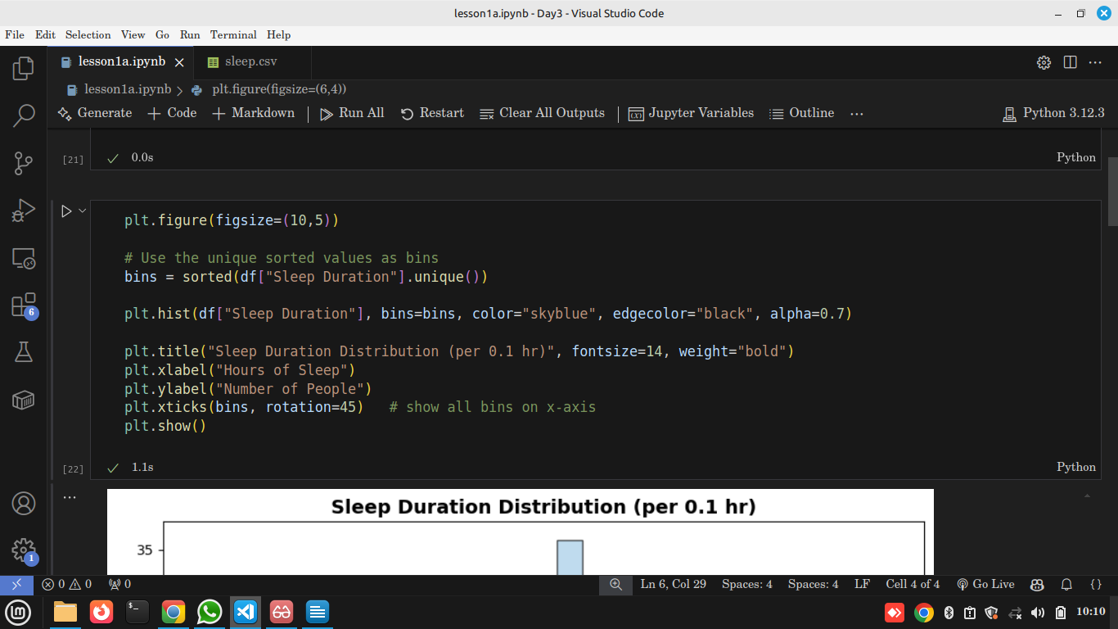

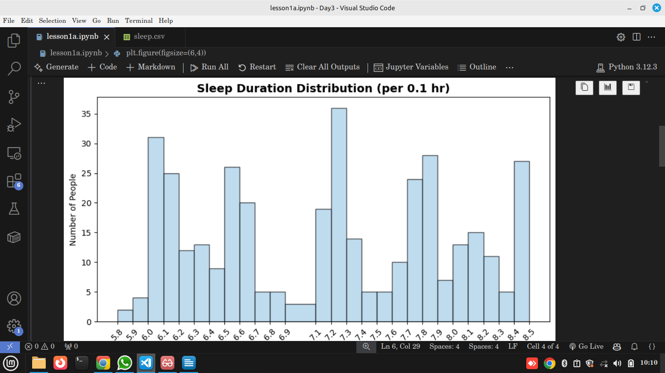
Output

📖 Explanation
- plt.hist(..., bins=bins) → histogram grouped by exact sleep duration values.
- xticks(bins) → every sleep hour (6.1, 6.2 …) is shown on the x-axis.
- alpha=0.7 → makes bars slightly transparent for clarity.

💡 Insights
- Most people sleep between 6.0 and 7.2 hours.
- Few people are below 6 hours → possible sleep-deprived cases.
- The data is not perfectly smooth, it has spikes at specific sleep values.

2️⃣ Boxplot – Sleep Duration by Gender
Practical
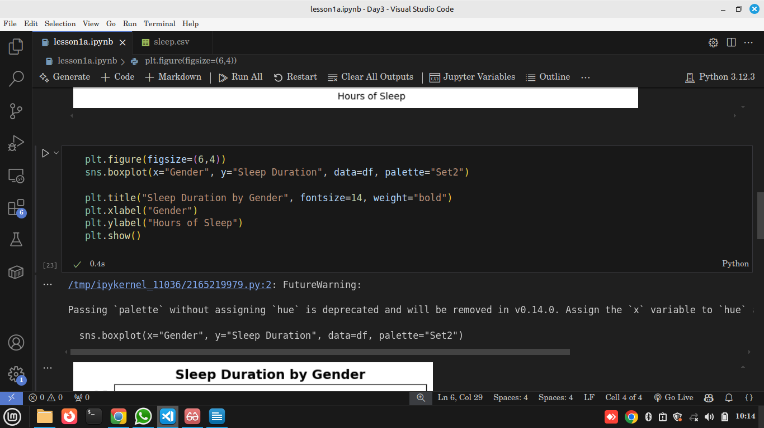

Output
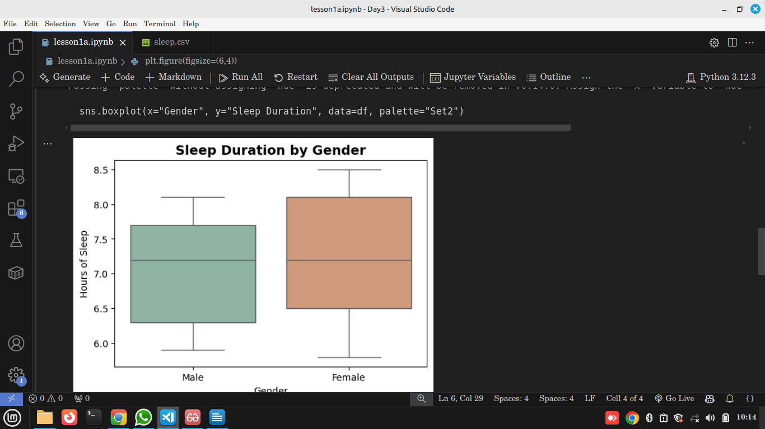

How to read the boxplot:
- The box itself → shows the middle 50% of the data (called the interquartile range, IQR).

Wha is Interquartile Range (IQR)
The box in a boxplot represents the middle 50% of the data.
To get it, we calculate quartiles (like slicing your data into 4 chunks):
Q1 (25th percentile) → 25% of the data falls below this value.
Q2 (50th percentile = median) → 50% of the data falls below this value.
Q3 (75th percentile) → 75% of the data falls below this value.
👉 The IQR = Q3 – Q1 → this range covers the “middle bulk” of your data.

- The line inside the box → the median (middle value of sleep duration).
- The whiskers (the vertical lines) → show the range of typical values (not outliers).
- Dots outside whiskers (if any) → outliers (people who sleep way less or more).

📖 Explanation
- sns.boxplot() → shows median, quartiles, and outliers.
- Each box represents the spread of sleep hours for males and females.

💡 Insights

On The Sleep Duration by Gender chart
- For Males:
  - Bottom of the box ≈ 6.3 hrs (Q1).
  - Top of the box ≈ 7.6 hrs (Q3).
  - Middle line inside box ≈ 7.1 hrs (median).
→ This means 50% of males sleep between 6.3 and 7.6 hrs.
- For Females:
  - Bottom of the box ≈ 6.1 hrs (Q1).
  - Top of the box ≈ 8.1 hrs (Q3).
  - Middle line inside box ≈ 7.2 hrs (median).
→ This means 50% of females sleep between 6.1 and 8.1 hrs.

✨ Why it’s useful
- The box ignores extreme values (outliers).
- It gives a clear picture of spread and consistency:
  - A short box = data is tightly clustered.
  - A tall box = data is spread out (more variability).
So in this case:
- Females have a taller box → their sleep hours are more variable.
- Males have a tighter box → more consistent sleep hours.

3️⃣ Scatterplot – Age vs Sleep Duration
Practical
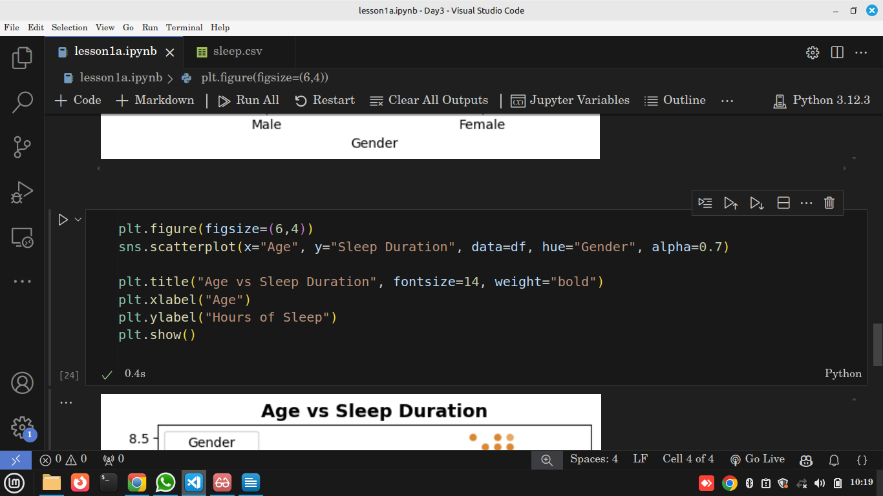

Output
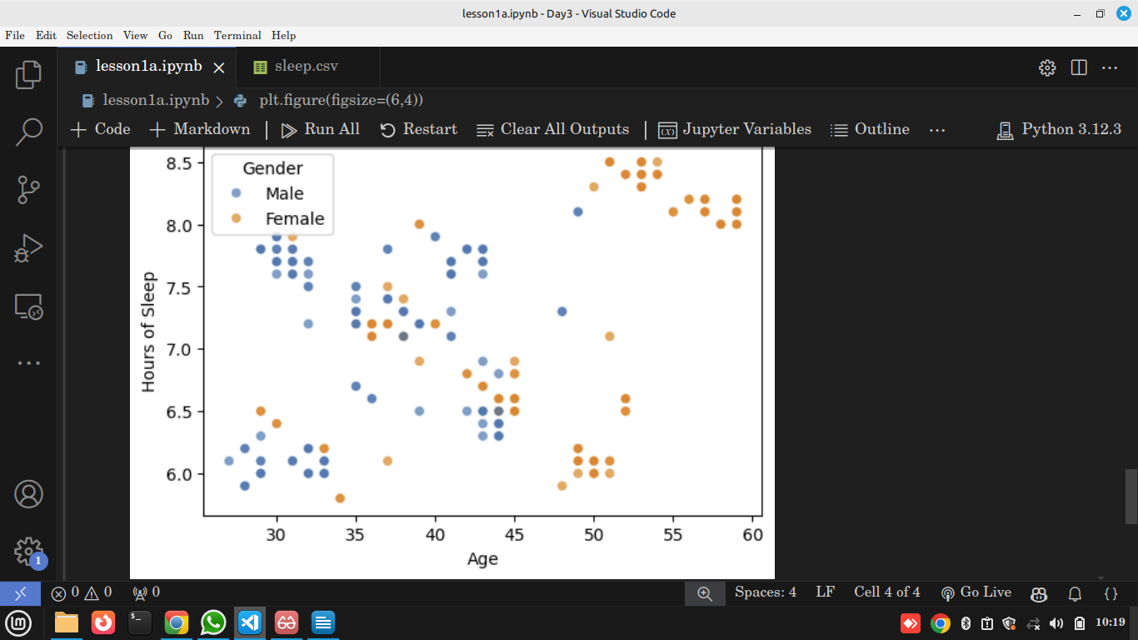

📖 Explanation
- sns.scatterplot() → each point = one person.
- hue="Gender" → separates males and females with different colors.

💡 Insights
- Sleep duration does not vary much with age in this sample.
- Both males and females cluster around 6–8 hours, showing consistent sleep behavior.

